ELEG 309 - Example Problems Chapter 4-1

**Example 4.1**

Figure 4.4 shows a circuit for charging a 12-V battery. If *vS* is a sinusoid with 24-V peak amplitude, find the fraction of each cycle during which the diodes conduct. Also, find the peak value of the diode current and the maximum reverse-bias that appears across the diode.

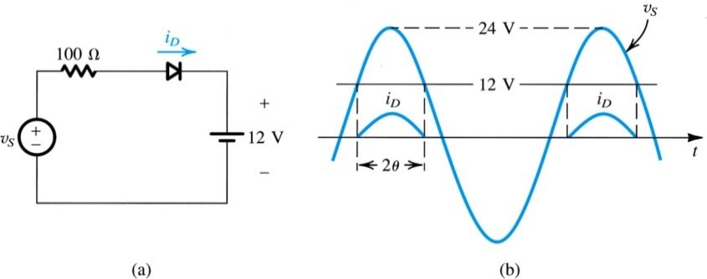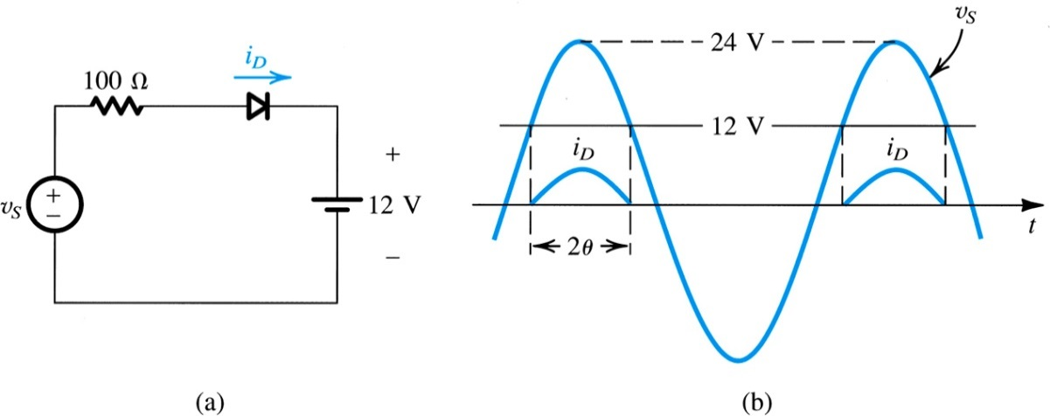

**Example 4.2**

Assuming the diodes to be ideal, find the values of *I* and *V* in the circuits of Fig. 4.6.

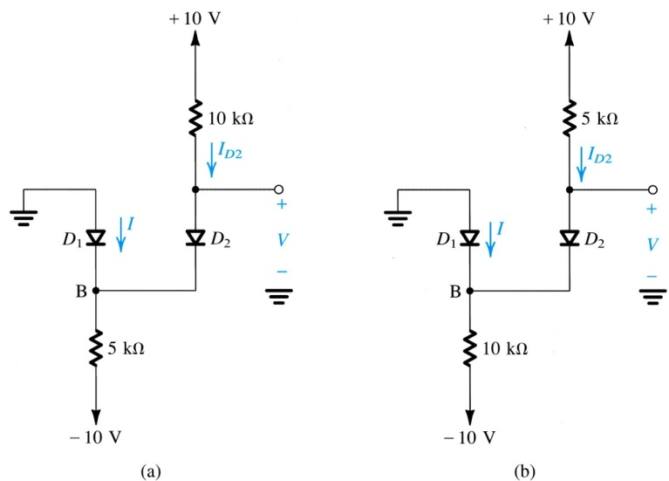

**Exercise 4.4**

Find the values of *I* and *V* in the circuits shown in Fig. E4.4

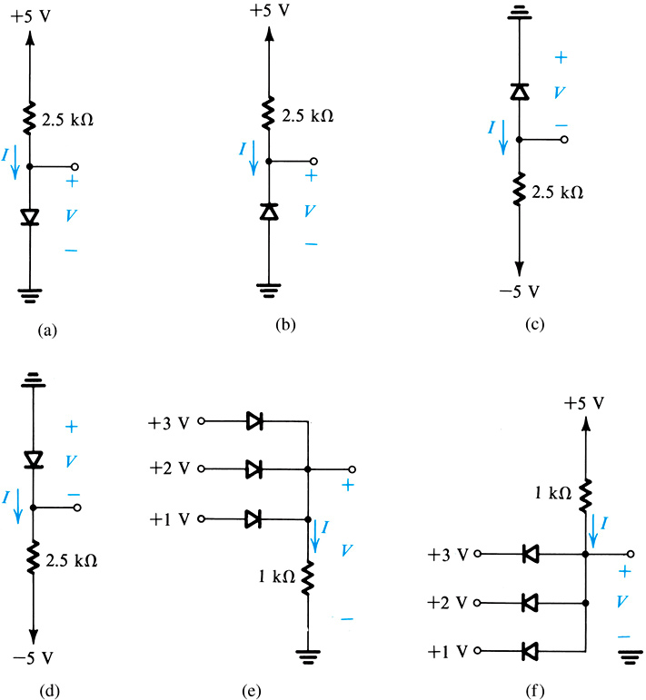



**Example 4.3**

A silicon diode said to be a 1-mA device displays a forward voltage of 0.7 V at a current of 1 mA. Evaluate the junction scaling constant *IS.* Whatscaling constants would apply for a 1-A diode of thesame manufacture that conducts 1 A at 0.7 V?